Cognizant Week 2 Assignment
Topic: Advanced SQL – Ranking and Window Functions
Your Name: Aditya Raj 6362534
Date: 29/06/2025

Table Schema and Data
CREATE TABLE Products (
ProductID INT,
ProductName VARCHAR(100),
Category VARCHAR(50),
Price DECIMAL(10,2)
);

INSERT INTO Products VALUES
(1, 'Laptop A', 'Electronics', 1000),
(2, 'Laptop B', 'Electronics', 900),
(3, 'TV A', 'Electronics', 900),
(4, 'Phone A', 'Electronics', 800),
(5, 'Shirt A', 'Clothing', 50),
(6, 'Shirt B', 'Clothing', 50),
(7, 'Jacket A', 'Clothing', 100);
✅ This creates the table and inserts sample data for testing.

Query 1: Using ROW_NUMBER()
SELECT *,
ROW_NUMBER() OVER (PARTITION BY Category ORDER BY Price DESC) AS row_num
FROM Products;
Output:
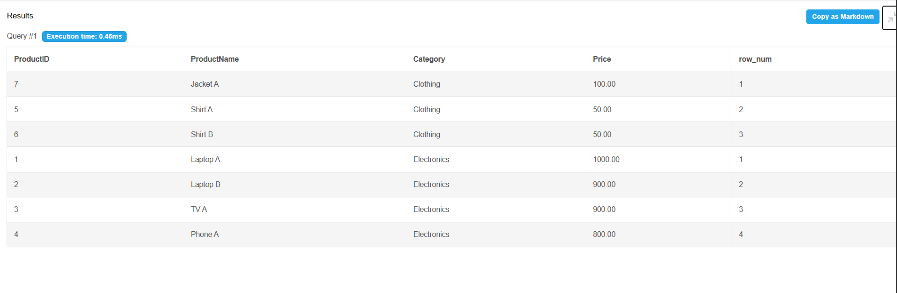

Query 2: Using RANK()
SELECT *,
RANK() OVER (PARTITION BY Category ORDER BY Price DESC) AS rank_num
FROM Products;
Output:
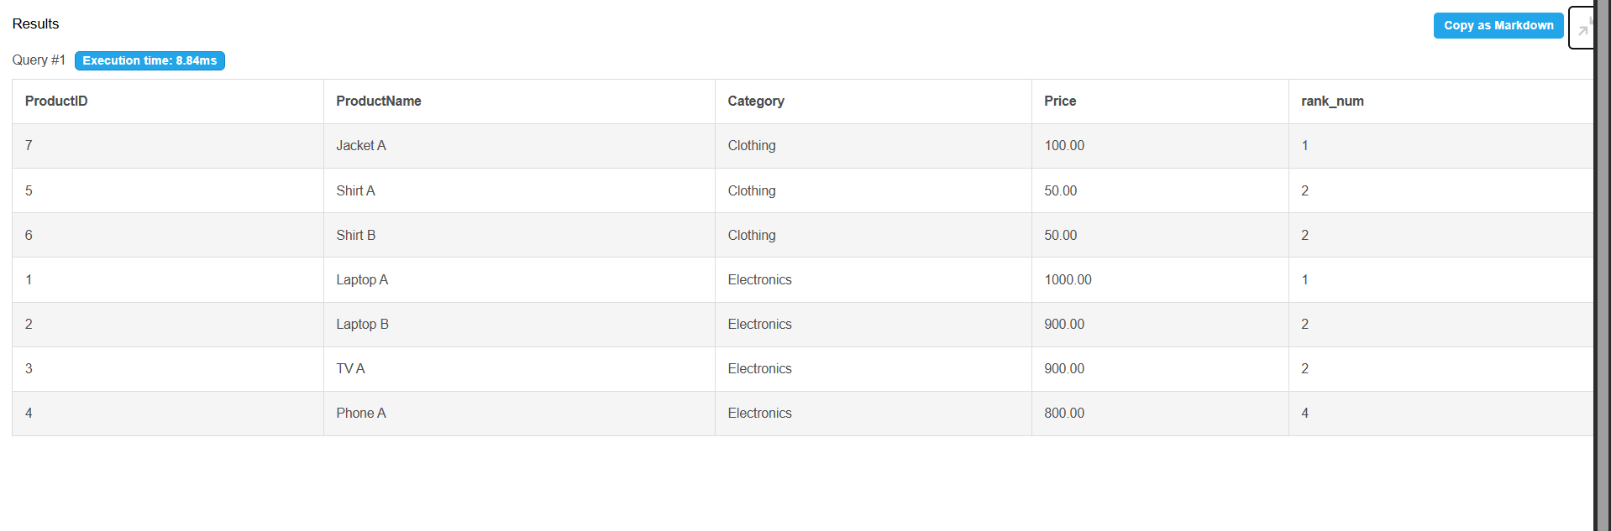

Query 3: Using DENSE_RANK()
SELECT *,
DENSE_RANK() OVER (PARTITION BY Category ORDER BY Price DESC) AS dense_rank_num
FROM Products;
Output:
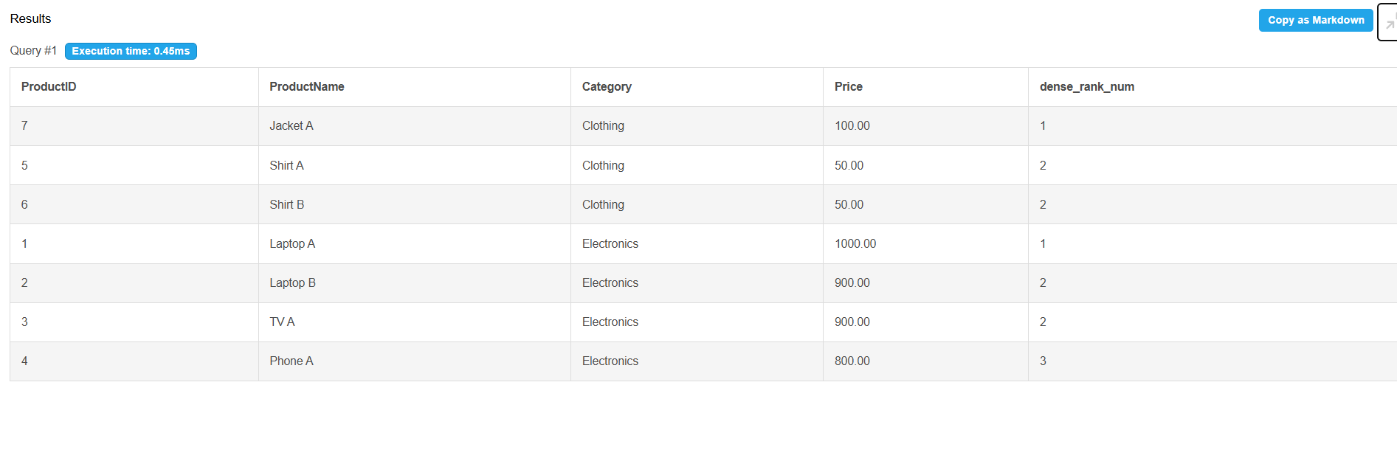

Query 4: Top 3 Most Expensive Products in Each Category
SELECT *
FROM (
SELECT *,
ROW_NUMBER() OVER (PARTITION BY Category ORDER BY Price DESC) AS row_num
FROM Products
) AS ranked
WHERE row_num <= 3;
Output:
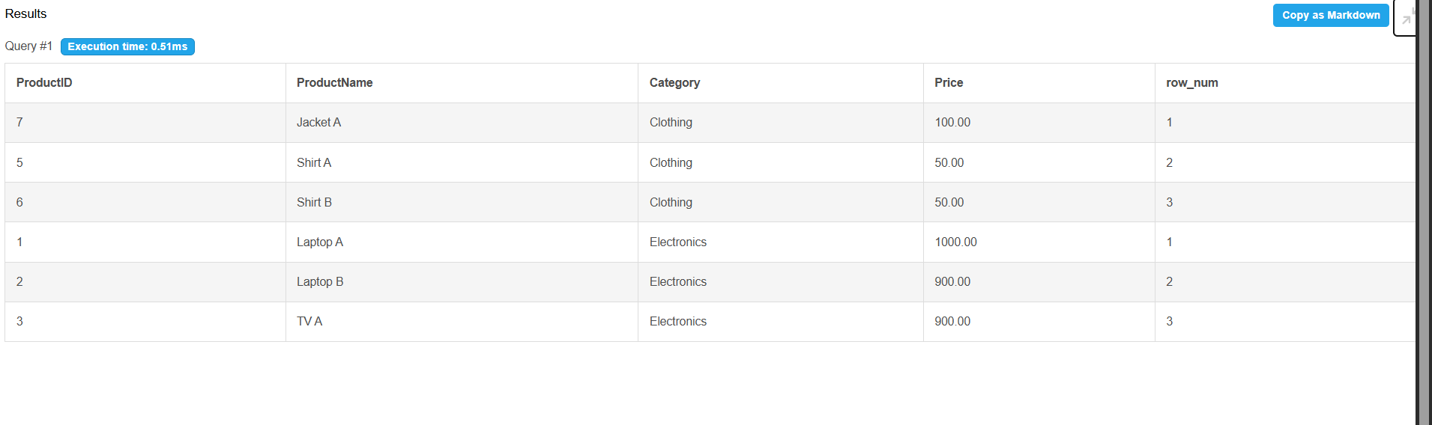

Conclusion
In this assignment, we practiced using ROW_NUMBER(), RANK(), and DENSE_RANK() with PARTITION BY and ORDER BY to rank products by price within each category. We also retrieved the top 3 most expensive products in each category using a subquery with ROW_NUMBER().

